Project Report: Financial Transactions and Loan Dashboard
Submitted by: M.Cheathana E25FA005
Tool used: Microsoft Power BI Desktop

1. Introduction
The Financial Transactions and Loan Dashboard is designed to analyze and present key performance indicators (KPIs) related to customer financial activities, loan status distribution, and transaction volumes over time. Built using Microsoft Power BI Desktop, this interactive dashboard provides financial analysts and management with clear insights into account usage, loan activity, and transaction metrics to support data-driven decision-making.

2. Objectives
- Monitor Financial Performance: Track overall transaction volumes, financial value, customer base size, and active loan counts.
- Analyze Transaction Breakdown: Categorize transaction activities by TypeName (Deposit, Transfer, Withdrawal, Payment) and monitor account distribution across categories.
- Evaluate Loan Status: Assess active vs. unallocated/blank loan distributions to understand portfolio health.
- Track Historical Trends: Observe transaction patterns across multi-year periods (2020 to 2026).
- Enable Interactive Filtering: Provide dynamic filtering capabilities by Year, Account Type, and Transaction Type for targeted analysis.

3. Dataset Description
The dashboard integrates data across key relational domains:

- Transactions Data: Contains detailed records of individual customer transactions including TypeName (Deposit, Payment, Transfer, Withdrawal), transaction counts, and total monetary transaction values.
- Accounts Data: Stores customer account details, account categories, and association with account type names.
- Loans Data: Captures loan portfolio details, total loan counts, and status categorization (Active vs (Blank)).
- Customers & Date Reference: Includes distinct customer IDs along with date metadata ranging from 2020 through 2026.

4. Data Preparation
To ensure data integrity and optimal report performance, the following data transformation steps were executed in Power Query Editor:

- Data Cleaning & Formatting: Cleaned raw transaction and loan tables, handled missing or blank status values, and set appropriate data types (Currency, Whole Number, Text, Date).
- Data Modeling: Established relationships between Accounts, Transactions, Customers, and Loan tables using standard primary/foreign key mappings.
- Number Formatting: Standardized metric displays to standard readable formats (e.g., Millions (125.19M), Thousands (1K), and currency formatting for tabular views).

5. Dashboard Components
The dashboard layout comprises the following visualization components:

KPI Cards
- Total Transaction Value: Displays 125.19M overall financial transaction volume.
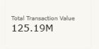
- Total Customers: Displays 1K distinct customer base.
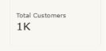
- Active Loans: Highlights 230 currently active loans.

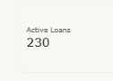

Visual Breakdown
- Total Accounts by TypeName (Clustered Column Chart): Displays equal distribution of account categories across Deposit, Payment, Transfer, and Withdrawal (~1,500 each).
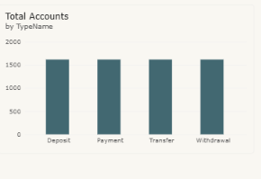
- Total Transactions by TypeName (Clustered Bar Chart): Compares total transactions across Deposit (15,065), Transfer (14,771), Withdrawal (14,706), and Payment (4,958).
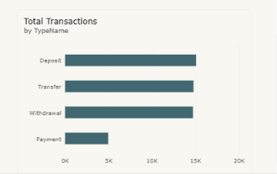

- Transactions Over Time (Line Chart): Illustrates transaction volume trends from 2020 through 2026, showing steady volume through 2023 followed by a decline in subsequent years.

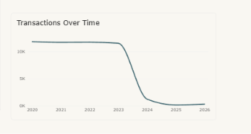
- Total Loans by StatusName (Donut Chart): Breakdown of 318 total loans showing Active loans (230, representing 72.33%) and (Blank) status loans (88, representing 27.67%).
The report features three dynamic slicers positioned on the right side of the dashboard to enable .

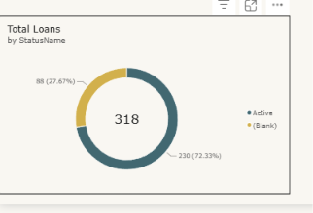

seamless interactive analysis:

- Year Slicer (Range Slider): Filters data across the calendar period 2020 to 2026.

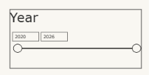
- Account Type Slicer (Dropdown): Allows user selection by account classification (Default set to All).

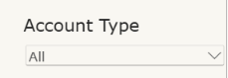
- Transaction Type Slicer (Dropdown): Filters dashboard visuals by transaction category (Default set to All).

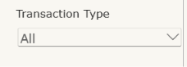

8. Key Findings
- Transaction Distribution: Deposits, Transfers, and Withdrawals dominate overall volume with each having ~14,700–15,000 transactions and ~$3.7M–$3.8M in total value. Payments account for a lower volume (4,958 transactions; ~$1.25M value).
- Loan Portfolio Health: Out of 318 total recorded loans, 72.33% (230 loans) are active, while 27.67% (88 loans) fall under unclassified/blank status.
- Volume Trend Analysis: Transaction activity remained strong and steady from 2020 through late 2023, after which activity significantly decreased entering 2024–2026.

9. Conclusion
The Financial Transactions and Loan Dashboard in Power BI provides a clear operational summary of organizational financial activity and loan management. By combining high-level KPI cards with granular category breakdowns and interactive year/type slicers, stakeholders can efficiently track performance trends, evaluate loan portfolio status, and gain key operational insights.

